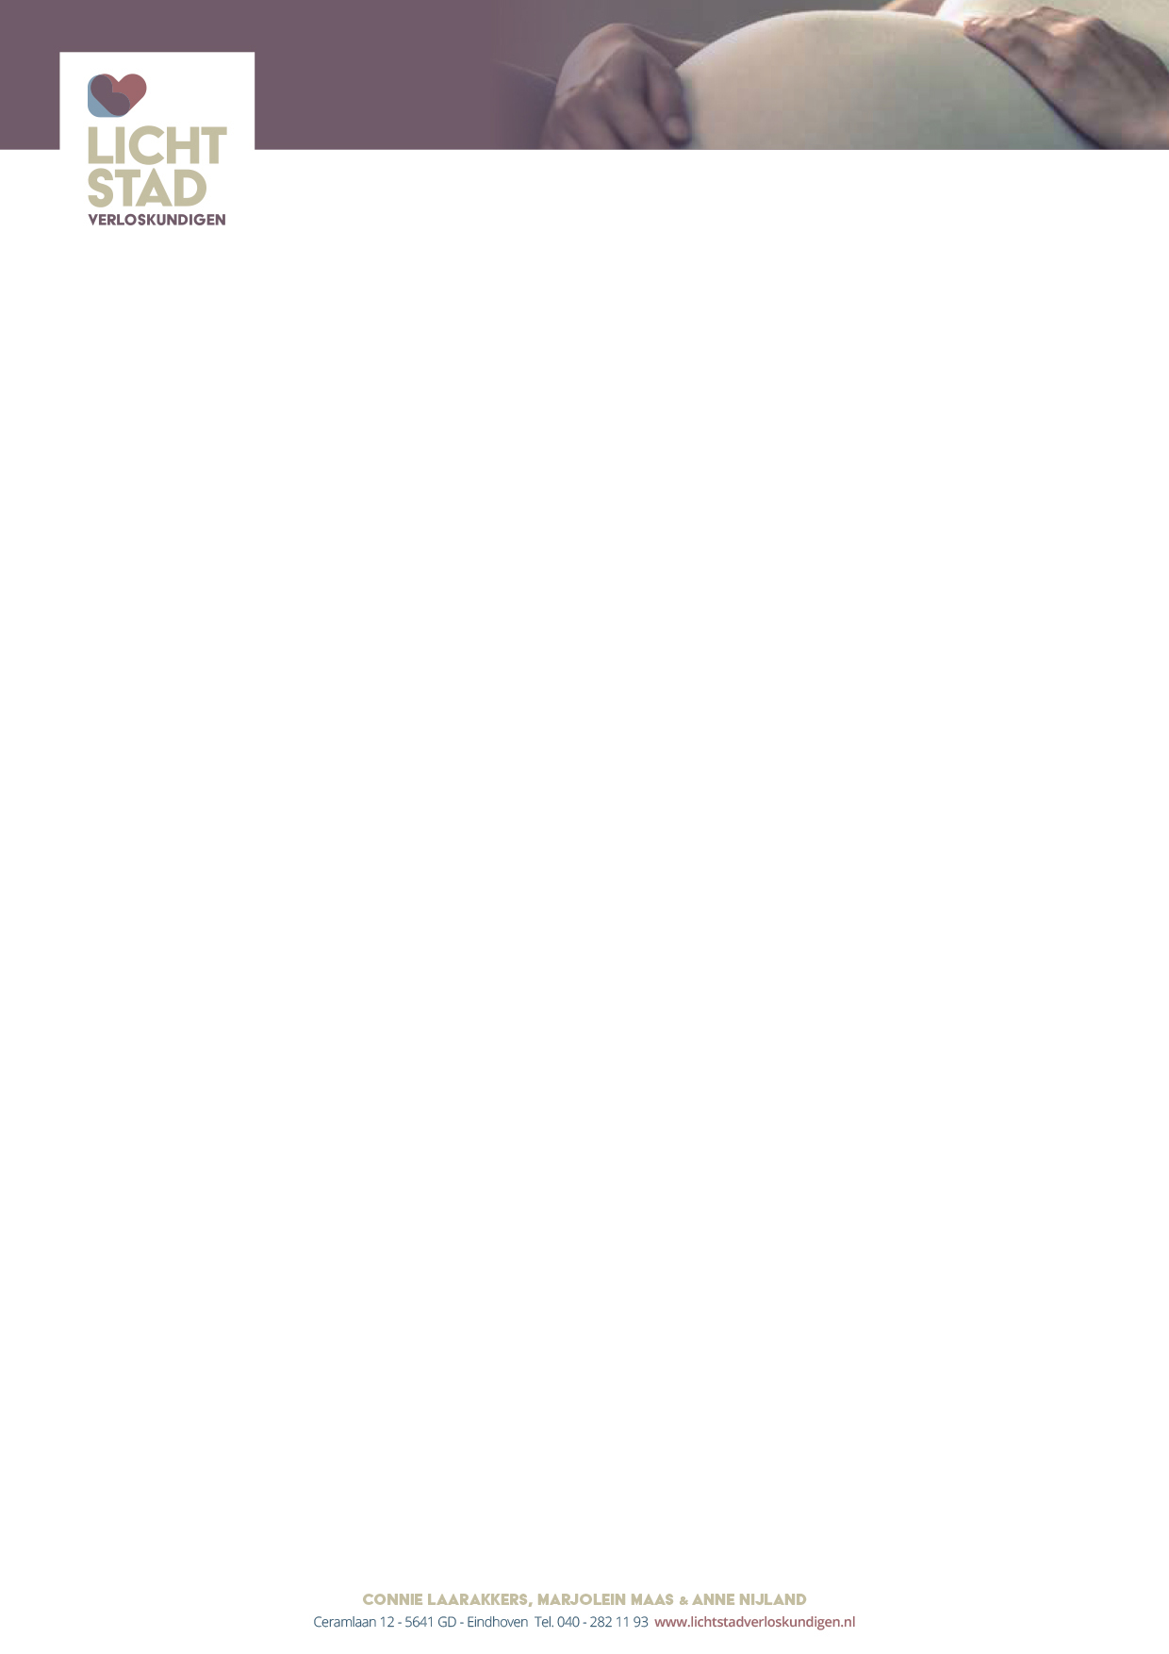

Breastfeeding Information

- Try to give the baby the breast for the first time within an hour after the birth. We or the maternity nurse will help you with this.
- The mother and the baby should be together as much as possible for the first few days.
- Try to put the baby to both breasts at least every two to three hours.
- More often than that is always fine.
- You should be busy with the baby for a maximum of 45 minutes per feeding. After that, drinking is no longer effective.
- If the baby, after 24 hours, has not yet started drinking at the breast: start pumping (in consultation with us).
- If the baby has lost more that 10% of his weight (the nurse weighs the baby) start supplementary feeding with breast and/or formula (in consultation with us). Also start pumping, depending on the cause of the weight loss.
- If breast feeding is going well, let the baby empty one breast completely; offer the second breast on request.
- A nipple shield is allowed, but use as little as possible. If the nipple shield is used before the nursing is well established, it is necessary to express the remaining milk after the feeding to get the breastfeeding going well.
- Drink enough and get enough rest

For cracked nipples
- Make sure the baby is latched on correctly: belly to belly. Big full mouth. Nose at the level of the nipple.
- Use ointment for cracked nipples.
- Use cotton compresses instead of disposable pads.
- Air out the breasts regularly; allow the nipples to dry in the air.

In case of clogged milk ducts (full, tight breasts)
- Nurse often.
- Cool the breast by laying cabbage leaves on them.
- If necessary, empty the breasts completely once a day by pumping.

