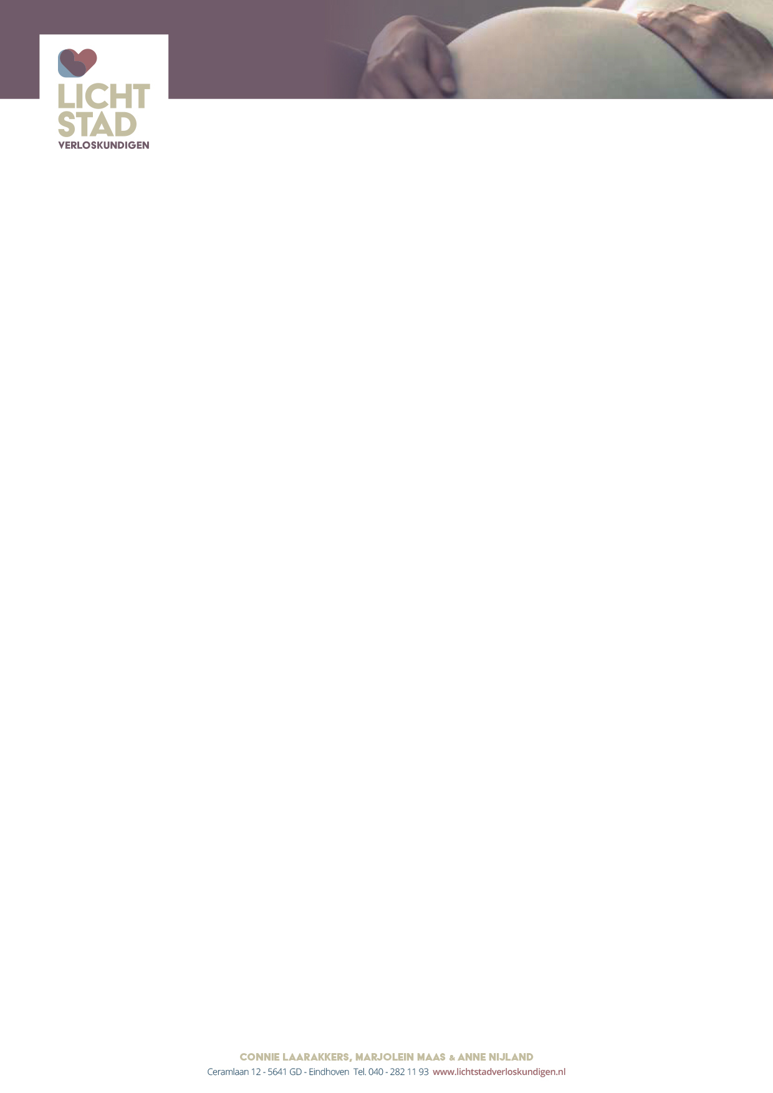

List of necessities

Things for the baby
- Digital thermometer (not an ear thermometer)
- 2 steel baby bottles (with a rubber stopper in the cap)
- 6 hydrophilic diapers
- 6 sweaters, 6 shirts or infant bodysuits (size 50-56)
- Baby bath, bucket or tummytub
- Baby clothes must be properly washed and rinsed before use. Do not use fabric softener because its residue may cause skin irritation.
- No bumpers in the cradle or cot.

Between the seventh and eighth month, you will be sent the Maternity Package by your insurance provider.
- Mattress protector
- 1 maternity mattress (60x90 cm)
- 6 disposable sheet
- 1 protective mattress cover
- 1 pack of maternity sanitary towels (maxipads)
- 2 boxes of wipes
- 1 pack of cotton
- Soap
- 1 plastic umbilical clamp
- 1 bottle of alcohol 70%

The delivery
- Minimum bed height 65 cm, for home or hospital birth. The bed can be raised with blocks which can be borrowed from 37 weeks gestation, from the home care shop at Kastelplein. Alternatively, you can use soft drink or beer crates.
- Towels and washcloths
- The room where you will deliver should be properly heated and lit.
- Nail Brush
- 2 buckets and a garbage bag
- Digital thermometer
- It is useful to have a hospital bag ready. (See below for contents)

Prepare a hospital bag for both home delivery and outpatient delivery
- Patient identity card from the hospital where you want to give birth (not necessary for home births)
- Clothes for the baby: Infant bodysuit, sweater, pants, hat, socks, jacket and blanket
- Maxi-cosi
- Clothes for yourself: Extra pair of socks and a t-shirt for during labour
- Pyjamas, bathrobe and slippers
- Toiletries
- Phone numbers of family and friends
- Camera (extra batteries)
- If necessary, dextrose-energy tablets.

